LAB 8

Software Development and Testing

|  |
| --- |
| **Group Members:** |
| CS-18118 Misha Akram |
| CS-18123 Iqra Irfan |
| CS-18136 Mujtaba Khan |
| CS-18141 Firdous Riaz |

**Q1: Using get pattern for both Lights and Cameras.**

**Code: -**

from tkinter import *

OPTIONS = ["Camera1","Camera2","Light1","Light2"]

GETPattern = ["details of a device","state of a device"]

window = Tk()

window.title("Get Pattern for lights and Cameras")

label1 = Label(window, text="Select GET pattern",width=200,font=("bold", 10))

label1.pack()

var = StringVar(window)

var.set(GETPattern[0]) # default value

x = OptionMenu(window, var, *GETPattern)

x.pack()

def go():

label2 = Label(window, text="Select Device",width=200,font=("bold", 10))

label2.pack()

variable = StringVar(window)

variable.set(OPTIONS[0]) # default value

w = OptionMenu(window, variable, *OPTIONS)

w.pack()

a = var.get()

if a == "details of a device":

def ok():

print ("value is:" + variable.get())

label = Label(window, text="Information Of Device Selected",width=200,font=("bold", 10))

label.pack()

value = variable.get()

if value == "Camera1":

i = " ID: 1, name: Samsung, description: 1000pixels, and model: 92"

label_1 = Label(window, text=i,width=200,font=("bold", 10))

label_1.pack() #lace(x=90,y=90)

elif value == "Camera2":

i = " ID: 2, name: Soni, description: 1000pixels, and model: 82"

label_2 = Label(window, text=i,width=200,font=("bold", 10))

label_2.pack() #lace(x=90,y=130)

elif value == "Light1":

i = " ID: 3, name: Thorax , description: 250V, and model: 23"

label_3 = Label(window, text=i,width=200,font=("bold", 10))

label_3.pack() #lace(x=90,y=180)

elif value == "Light2":

i = " ID: 4, name: milestone, description: 250V yellow, and model: 72"

label_4 = Label(window, text=i,width=200,font=("bold", 10))

label_4.pack()#lace(x=90,y=230)

elif a == "state of a device":

def ok():

#print ("value is:" + variable.get())

label = Label(window, text="State Of Device Selected",width=200,font=("bold", 10))

label.pack()#lace(x=90,y=53)

value = variable.get()

if value == "Camera1":

i = " Active"

label_1 = Label(window, text=i,width=200,font=("bold", 10))

label_1.pack()#lace(x=90,y=90)

elif value == "Camera2":

i = " NOT Active"

label_2 = Label(window, text=i,width=200,font=("bold", 10))

label_2.pack()#lace(x=90,y=130)

elif value == "Light1":

i = " Active"

label_3 = Label(window, text=i,width=200,font=("bold", 10))

label_3.pack()#lace(x=90,y=180)

elif value == "Light2":

i = " NOT Active"

label_4 = Label(window, text=i,width=200,font=("bold", 10))

label_4.pack()#lace(x=90,y=230)

button = Button(window, text="OK", command=ok)

button.pack()

button1 = Button(window, text="stateOK", command=go)

button1.pack()

window.mainloop()

**Output: -**

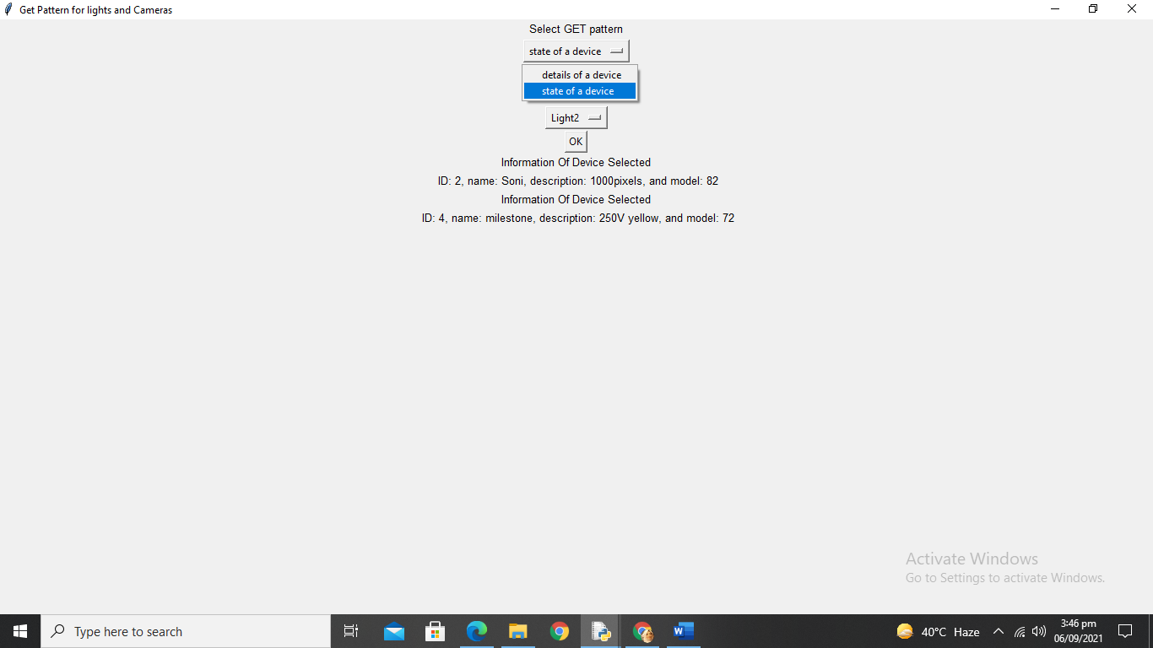

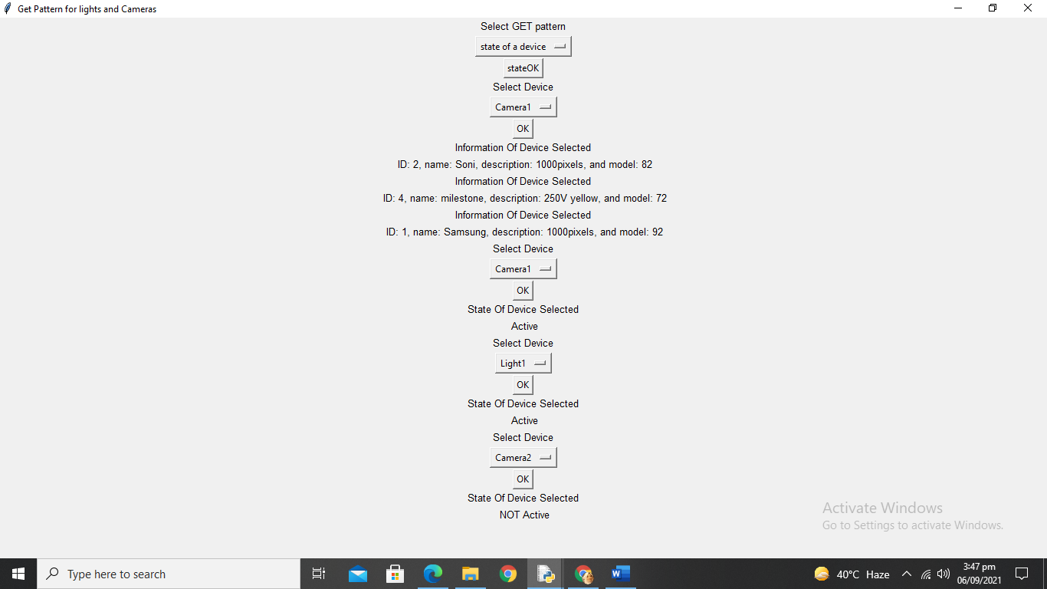

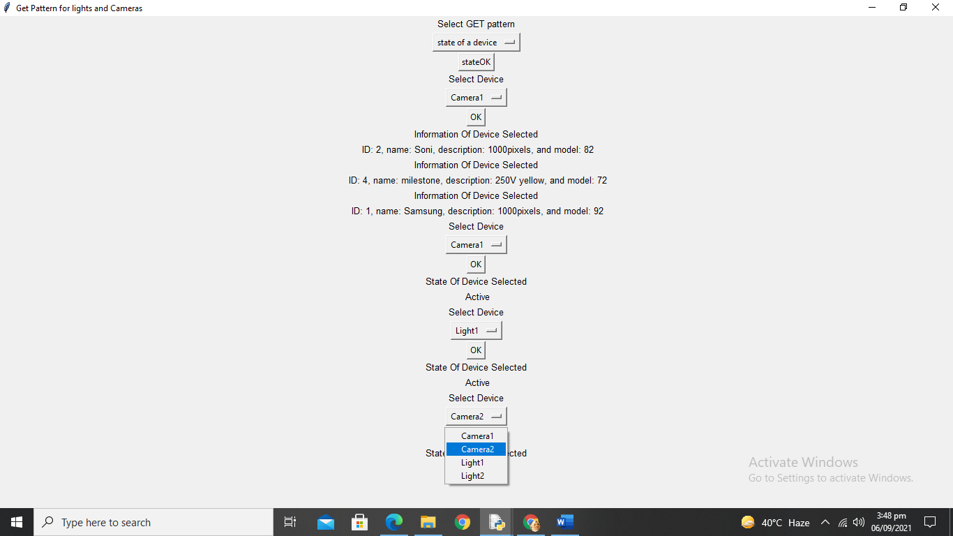

**Q2: Using set pattern for lights.**

**Code: -**

from tkinter import *

OPTIONS = ["Light1","Light2"]

OPTIONSS = ["Turn ON","Turn OFF"]

window = Tk()

window.title("Set Pattern for lights")

label1 = Label(window, text="One Device One Operation Method",width=200,font=("bold", 10))

label1.pack()

label1 = Label(window, text="Select Device",width=200,font=("bold", 10))

label1.pack()

var = StringVar(window)

var.set(OPTIONS[0]) # default value

x = OptionMenu(window, var, *OPTIONS)

x.pack()

def go():

label2 = Label(window, text="Select Operation",width=200,font=("bold", 10))

label2.pack()

variable = StringVar(window)

variable.set(OPTIONSS[0]) # default value

w = OptionMenu(window, variable, *OPTIONSS)

w.pack()

a = var.get()

def ok():

if a == "Light1":

value = variable.get()

if value == "Turn ON":

label2 = Label(window, text="Status of light1 is made Active",width=200,font=("bold", 10))

label2.pack()

elif value == "Turn OFF":

label2 = Label(window, text="Status of light1 is made NOT Active",width=200,font=("bold", 10))

label2.pack()

elif a == "Light2":

value = variable.get()

if value == "Turn ON":

label2 = Label(window, text="Status of light2 is made Active",width=200,font=("bold", 10))

label2.pack()

elif value == "Turn OFF":

label2 = Label(window, text="Status of light2 is made NOT Active",width=200,font=("bold", 10))

label2.pack()

button = Button(window, text="OK", command=ok)

button.pack()

button1 = Button(window, text="OK", command=go)

button1.pack()

window.mainloop()

**Output: -**

